***Bank Database ER Diagram***

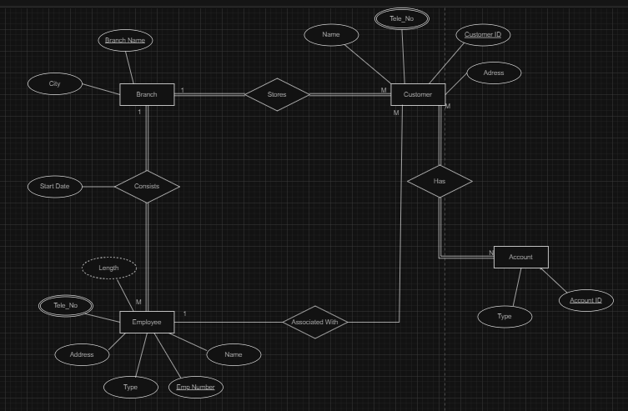

**Assumptions**

* One employee can act as a personal banker or loan officer of more customers. Each customer associated with only one employee.
* Employees can consist of only one branch. They can’t work for more branches.
* Customer can have more accounts and an account can be held by more than one customer. Every customer has a account and every account has one or more customers.